BACK-PROPOGATION---SINGLE-NEURON

# AIM:

To write a python program to perform Back Propagation with Single Neuron.

# EQUIPMENTS REQUIRED:

1. Hardware –PCs
2. Anaconda–Python3.7Installation/GoogleColab/JupiterNotebook

# RELATED THEORITICAL CONCEPT:

## Training Dataset:

Trainingdataisanextremelylargedatasetthatisusedtoteachamachinelearningmodel.Training data is used to teach prediction models that use machine learning algorithms how to extract featuresthatarerelevanttospecificbusinessgoals.ForsupervisedMLmodels,thetrainingdatais labeled.ThedatausedtotrainunsupervisedMLmodelsisnotlabeled.Trainingdataisalsoknown asatrainingset,trainingdatasetorlearningset.

## Test data:Testdataisdatawhichhasbeenspecificallyidentifiedforuseintests,typicallyofacomputer

program.Somedatamaybeusedinaconfirmatoryway,typicallytoverifythatagivensetofinput toagivenfunctionproducessomeexpectedresult.

## Backward propagation:

Backpropagation(backwardpropagation)isanimportantmathematicaltoolforimprovingthe accuracyofpredictionsindataminingandmachinelearning.Essentially,backpropagationisan algorithmusedtocalculatederivativesquickly.

# Algorithm:

1. InputsX,arrivethroughthepreconnectedpath.
2. InputismodeledusingrealweightsW.Theweightsareusuallyrandomlyselected.
3. Calculatetheoutputforeveryneuronfromtheinputlayer,tothehiddenlayers,totheoutput layer.
4. Calculatetheerrorintheoutputs.
5. Travelbackfromtheoutputlayertothehiddenlayertoadjusttheweightssuchthattheerror isdecreased.

Keep repeating the process until the desired output is achieved.

# PROGRAM:

/*

Programtoimplementrandomclassification.Developedby :moneesh

RegisterNumber: 212219040081

*/

importnumpyasnpi=1.5

w_o=0.8 y=0.5 r=0.01

defdc_dw(a,y,i):

dc_da=2*(a-y) da_dw=i

returndc_da*da_dw

w=[w_o] a=[w_o*i]

forjinrange(0,100):a.append(w[-1]*i)

w.append(w[-1]-r*dc_dw(a[-1],y,i)) if(a[-1]-y)**2<0.001:

break print(a) print("") print(w)

# OUTPUT:

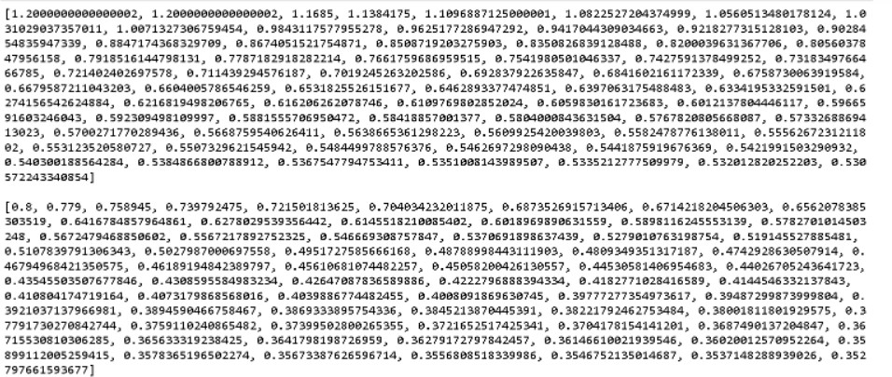

**RESULT:**

Thus the Back Propagation with Single Neuron was successfully implemented using python programming.